**Abstract**

Nowadays almost every company, firm and organization need a system to control and manage their activities as well as the required information about their staff, employees or customers. Managers prefer to have a system on their computers in order to monitor all activities and also to access important information about the company that they run whenever they want. In this case, universities are not exception and they need a system to manage all the data about their staff, professors and students as well as other important information about faculties, courses, grades and etc. That kind of system will help the board of directors of the university to access the information that they need at the moment and edit or delete them. The system also increase the safety, accuracy and speed of accessing to data. The aim of this project is to design a University management system for the mentioned benefits.

**Document revision history:**

* 1. October21. 2017 – write a proposal about the project
  2. October26. 2017 – presenting the idea to the class
  3. October28, 29. 2017 – writing the requirements document
  4. October31. 2017 – considering more details and complete requirements document

**Introduction**

This system as I mentioned earlier is going to be used by a single university. The system will be designed in a way that allows university administrators to manage all their data such as basic information about the faculties, staff, professors and students. Administrators can view, add, edit and delete data from the system. Although there will be more than single role for this project, but for now the focus of the project will be just on administrator and I leave defining professors and students role for later.

The following picture shows the home page of the system and its features.



As it is shown in the picture, the tap bar includes “faculty profile”, “staff profile”, “professors’ profile”, “students’ profile”, “courses” and “grades”. However I am still thinking that I have to add more features to the homepage. Other features which I am in doubt that will I have enough time to implement them are ‘**login and logout**’, ‘**search box**’, ‘**print pdf**’ and ‘**backup of data**’.

Faculty profile includes following information

* Faculty number
* Faculty name
* Dean of faculty
* Number of classes
* Telephone
* Email

Following picture shows the faculty profile page of the system.

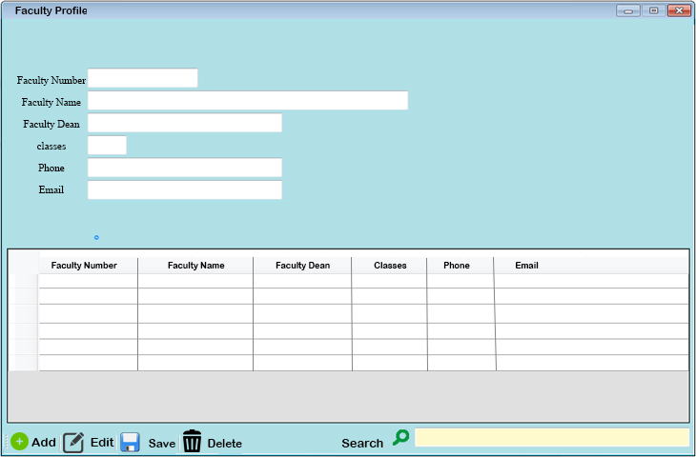

The search box will help administrators to find the needed information quicker. Data storing and filtering are other features which can be added to this page.

Staff profile includes information about all the employees of the faculty except professors, and those information are

* Name
* Surname
* Date of Birth
* Employment date
* JMBG
* Mobile Number
* Address

Professors’ profile page includes following information about all the professors and deans of faculty

* Professor ID
* Name
* Surname
* JMBG
* Academic degree
* Field of study
* Mobile Number
* Email
* Address

In addition the information which are mentioned above, in this page, administrator can choose which courses are going to be taught by which professor. Again search box in this page, helps administrator to find the required information much faster rather than to go through all data one by one and search for specific information.

Following picture shows the students’ profile page in the system.

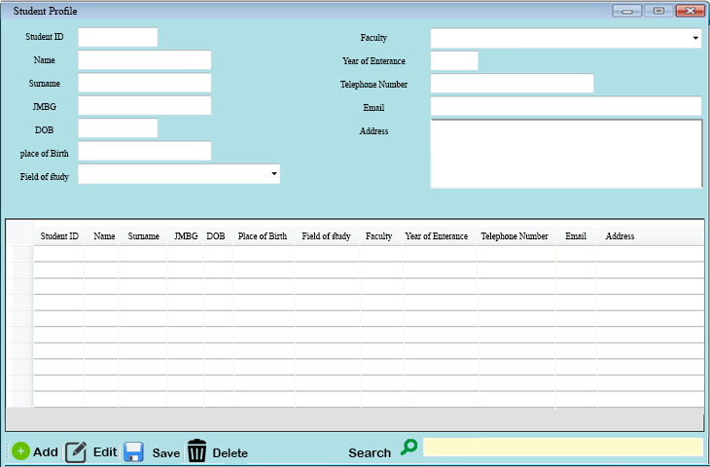

Students’ profile page includes following information

* Student ID
* Name
* Surname
* JMBG
* Date of Birth
* Field of study
* Faculty
* Year of entrance
* Mobile Number
* Email
* Address

In this page, courses can be registered to the students and later can be edited or deleted by the user who has permission to do that. Sorting and filtering students in this page is another feature which may be implemented later. Same to the other pages, search box helps user to find required data faster.

Courses includes basic information such as:

* Course number
* Course name
* Course type
* Department

In addition to above information, user can view, add, edit and delete data from courses data. Also system can show which course are presented by which professors and if a professor teaches more than single courses.

Grades allow user to enter students’ grades to the system. This part should be done by the professors since the administrators do not have any business with the grades.

As I mentioned earlier I am thinking to add print pdf and backup of data to the system. Print pdf helps the user to print the required form of each professor, student and so on, while backup of data allows user to have a backup from the data of the system, if anytime by mistake, he/she deleted some data.

**User requirements**

As I mentioned earlier in the introduction, the system allows users to manage all the data which is related to a single university. We all know that each big university includes huge amount of data which is about its staff, professors and students and other basic information about its faculties and courses which are offered to students. Therefore managing that information and accessing to them in short time is very important for director and board of university.

Nowadays system designers try their best to design and run a system which is simple and understandable for the users but also has enough features and capabilities to handle difficult and complex tasks. If system starts to be slow or gives many errors during the processes, the user can’t tolerate that and he/she will quit from that system and going to try another one. Therefore system performance which includes few factors such as response time is very important for us. I should consider that for each type of task, which reaction should be shown to the user in order to help him to understand what exactly is happening at the moment in the system.

Capacity of the system is another important factor. Here the system is going to work with huge database and it should have enough space for that. Database should be well secured